#### Chilkat Lake Sockeye Salmon

Sara Miller, Steve Heinl

Chilkat Lake, located approximately 44 river km upstream from the city of Haines, supports one of the largest runs of sockeye salmon in Southeast Alaska. Chilkat Lake sockeye salmon are primarily harvested in the District 15 commercial drift gillnet fishery in northern Lynn Canal. Smaller but unknown portions of the Chilkat run are harvested in the commercial purse seine fisheries that target pink salmon in Icy and northern Chatham straits (Ingledue 1989; Gilk-Baumer et al. 2015) and in subsistence fisheries in Chilkat Inlet and in the Chilkat River. Scale pattern analysis has been used to apportion District 15 commercial harvests of sockeye salmon bound for Chilkat Lake and other systems in the area (McPherson 1990). Chilkat Lake sockeye salmon escapements have been estimated through weir counts (1967–1993), weir counts with concurrent mark–recapture estimates (1994 and 1995, 1999–2007), mark–recapture estimates only (1996–1998), Dual-frequency Identification Sonar (DIDSON) counts with concurrent mark–recapture estimates (2008–2016), and DIDSON counts only from 2017 on (Eggers et al. 2010; Sogge and Bachman 2014; Bednarski et al. 2017; Zeiser et al. 2020; Ransbury et al. 2021). Visual weir counts provided minimum estimates of escapement due to flow reversals, turbid water, and frequent lowering of a boat gate in the middle of the weir, all of which potentially allowed fish to pass undetected. Conversely, mark–recapture estimates may be greatly inflated, but may provide an index of escapement (Bednarski et al. 2017). DIDSON counts are also considered minimum estimates of escapement due to undetected passage of small numbers of fish at night during flow reversals; however, confidence in DIDSON counts is much greater than in the visual weir counts (Bednarski et al. 2017).

The current biological escapement goal range of 70,000–150,000 sockeye salmon (Eggers et al. 2008, 2010) was established in 2009. Following a comprehensive review of historical stock assessment data (Bednarski et al. 2017), the escapement goal analysis was last updated in 2018 by Miller and Heinl (2018; brood years 1976−2012; calendar years 1976–2016­­). With the accumulation of more brood year returns (brood years 2013−2018), the escapement goal was recently reviewed using a similar methodology to Miller and Heinl (2018); an age-structured state-space spawner-recruit model was fit data on abundance, harvest, age composition, and coefficients of variation to examine the effect of autocorrelation on recruits, to account for multiple overlapping methods of escapement enumeration and missing data (age composition was considered unknown in the model for years 1996–1998 when the weir was not operated; Figure 1 and Figure 2). DIDSON escapement counts were treated as the ‘true’ counts and the weir counts and mark–recapture estimates of escapement were treated as indices of escapement in the state-space models. Despite the addition of sixyears of data (Figure 3), the resulting parameter estimates were very similar to those estimated Miller and Heinl (2018). As a result, the current biological escapement goal of 70,000–150,000 sockeye salmon, counted with the DIDSON system at the Chilkat Lake weir site, remains unchanged.

Based on the 2023 analysis with the updated brood year data (brood years 1976−2018), the posterior median of escapement leading to maximum sustained yield from the output of the state-space model was 96,300 spawners (95% credible interval 65,600–260,900 spawners; Table 1). The probability of achieving 90% of maximum sustained yield (MSY) at the upper and lower bounds of the current escapement goal is estimated to be 65% and 31%, respectively (Figure 4), and an average 64% over the entire escapement goal range. Yield would be maximized at escapements near *S*MSY (near 84% probability of achieving 90% of MSY; Figure 4). These probabilities improve substantially with respect to achieving 80% of MSY. The escapement goal review committee recommended maintaining the current biological escapement goal of 70,000–150,000 fish counted with the DIDSON system at the Chilkat Lake weir site.

**References**

Bednarski, J. A., M. M. Sogge, S. E. Miller, and S. C. Heinl. 2017. A comprehensive review of Chilkat Lake and River sockeye salmon stock assessment studies. Alaska Department of Fish and Game, Fishery Manuscript Series No. 17-06, Anchorage.

Eggers, D. M., J. H. Clark, R. L. Bachman, and S. C. Heinl. 2008. Sockeye salmon stock status and escapement goals in Southeast Alaska. Alaska Department of Fish and Game, Special Publication No. 08-17, Anchorage.

Eggers, D. M., R. L. Bachman, and J. Stahl. 2010. Stock status and escapement goals for Chilkat Lake sockeye salmon in Southeast Alaska. Alaska Department of Fish and Game, Fishery Manuscript No. 10-05, Anchorage.

Gilk-Baumer, S. E., S. D. Rogers Olive, D. K. Harris, S. C. Heinl, E. K. C. Fox, and W. D. Templin. 2015. Genetic mixed stock analysis of sockeye salmon harvests in selected northern Chatham Strait commercial fisheries, Southeast Alaska, 2012–2014. Alaska Department of Fish and Game, Fishery Data Series No. 15-03, Anchorage.

Ingledue, D. 1989. Hawk Inlet shore purse seine fishery, 1989. Alaska Department of Fish and Game, Division of Commercial Fisheries, Regional Information Report No. 1J89-31, Juneau.

McPherson, S. A. 1990. An inseason management system for sockeye salmon returns to Lynn Canal, southeast Alaska. M. S. Thesis, University of Alaska, Fairbanks.

Miller, S. E., and S. C. Heinl. 2018. Chilkat Lake sockeye salmon escapement goal review. Alaska Department of Fish and Game, Fishery Manuscript Series No. 18-05, Anchorage.

Ransbury, S. R., N. L. Zeiser, J. A. Bednarski, S. C. Heinl, C. S. Jalbert, and S. E. Miller. 2021. Stock assessment study of Chilkat Lake and River sockeye salmon, 2017–2020. Alaska Department of Fish and Game, Fishery Manuscript Series No. 21-06, Anchorage.

Sogge, M. M., and R. L. Bachman. 2014. Operational Plan: Stock assessment studies of Chilkat River adult salmon. Alaska Department of Fish and Game, Regional Operational Plan ROP.CF1J.14-03, Douglas.

Zeiser, N. L., S. R. Ransbury, S. C. Heinl, and S. E. Miller. 2020. Operational plan: Chilkat Lake salmon weir enumeration and sampling procedures, 2020–2022. Alaska Department of Fish and Game, Regional Operational Plan ROP.CF.1J.2020.02, Douglas.

**Table 1.**–Parameter estimates from the state-space model fitted to the Chilkat Lake sockeye salmon data for calendar years 1976–2022 (brood years 1976–2018). Posterior medians are point estimates; the 2.5th and 97.5th percentiles define 95% credible intervals for the parameters. The parameter ln(*a'*)is the log-normal bias-corrected alpha parameter. Biological benchmarks based on the log-normal bias-corrected alpha parameter.

|  |  |  |  |  |  |
| --- | --- | --- | --- | --- | --- |
| Parameter | 2.5% | Median | 97.5% | Mean | Posterior CV |
| *a* | 1.76 | 2.86 | 4.86 | 2.98 | 0.27 |
| ln(a) | 0.56 | 1.05 | 1.58 | 1.06 | 0.25 |
| ln(a') | 0.78 | 1.26 | 1.90 | 1.28 | 0.22 |
| *b* | 1.60E-06 | 5.42E-06 | 9.33E-06 | 5.41E-06 | 0.36 |
| *f* | 0.09 | 0.41 | 0.73 | 0.41 | 0.39 |
| *sR* | 0.46 | 0.57 | 0.73 | 0.58 | 0.12 |
| *S*EQ | 162,084 | 234,223 | 611,713 | 275,634 | 0.49a |
| *S*MAX | 107,233 | 184,519 | 623,391 | 235,121 | 0.71a |
| *S*MSY | 65,566 | 96,257 | 260,869 | 114,361 | 0.52a |
| *U*MSY | 0.35 | 0.52 | 0.70 | 0.52 | 0.17 |
| D | 16.64 | 24.52 | 36.03 | 24.96 | 0.20 |
| *p*4 | 0.04 | 0.05 | 0.07 | 0.05 | 0.14 |
| *p*5 | 0.53 | 0.56 | 0.59 | 0.56 | 0.03 |
| *p*6 | 0.35 | 0.38 | 0.42 | 0.38 | 0.04 |
| *q*m-r | 1.48 | 1.60 | 1.73 | 1.60 | 0.04 |
| *q*weir | 0.65 | 0.74 | 0.84 | 0.74 | 0.06 |

aThe coefficients of variation for the reference points *S*EQ, *S*MAX, and *S*MSYwere calculated as (97.5th percentile–2.5th percentile)/3.92/posterior median point estimate. If the posterior median is approximately normal, then the lower and upper bound of the 95% credibility are both ~1.96 × standard errors from the median point estimate.

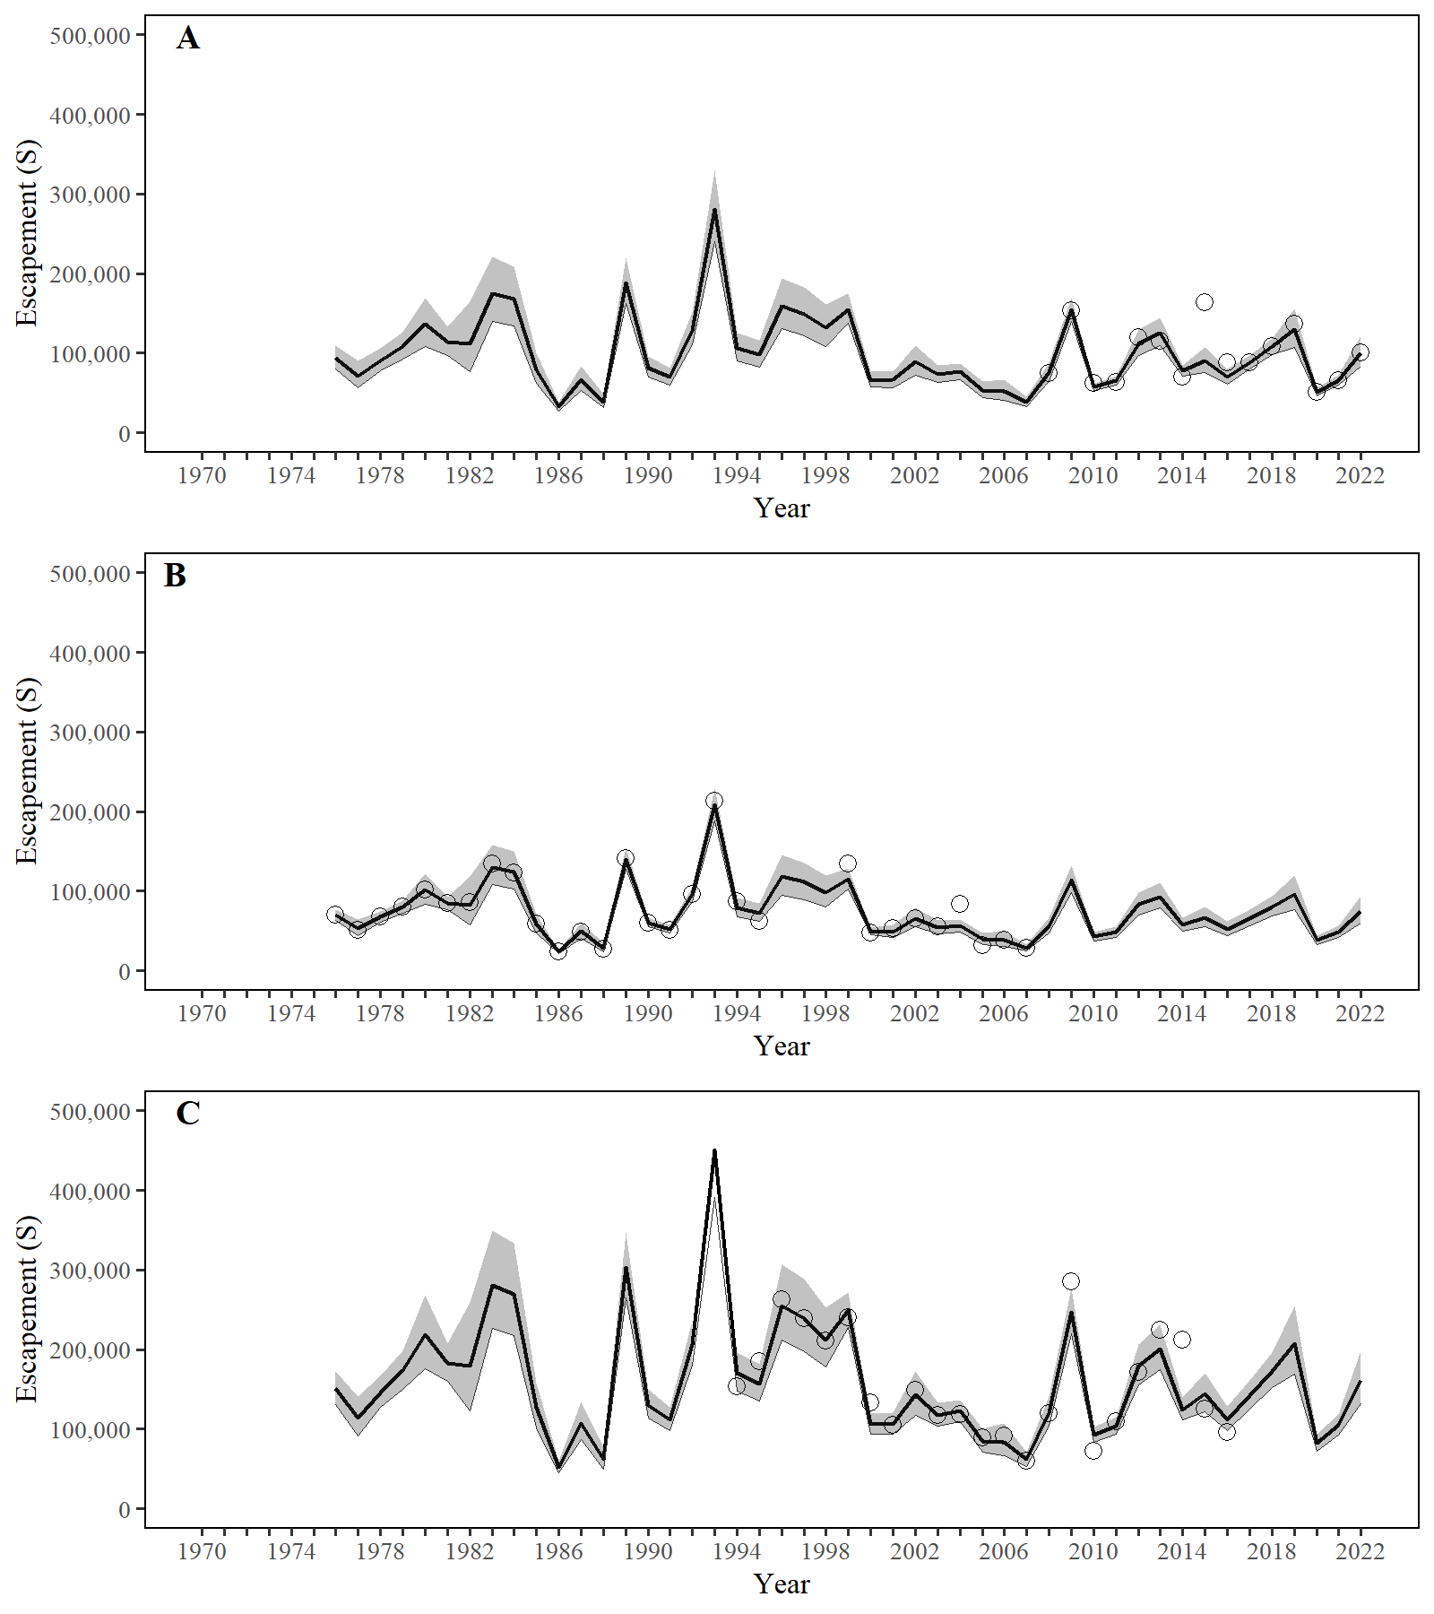

**Figure 1.**– Point estimates (posterior median; solid line) and 95% credible intervals (shaded areas) of escapement (Figure A) and indices of escapement (Figure B and Figure C) from a state-space model of Chilkat Lake sockeye salmon, calendar years 1976–2022. Figure A is the observed (open circles) and modeled (solid line) DIDSON counts, Figure B is the observed (open circles) and modeled (solid line) weir counts, and Figure C is the observed (open circles) and modeled (solid line) mark–recapture estimates.

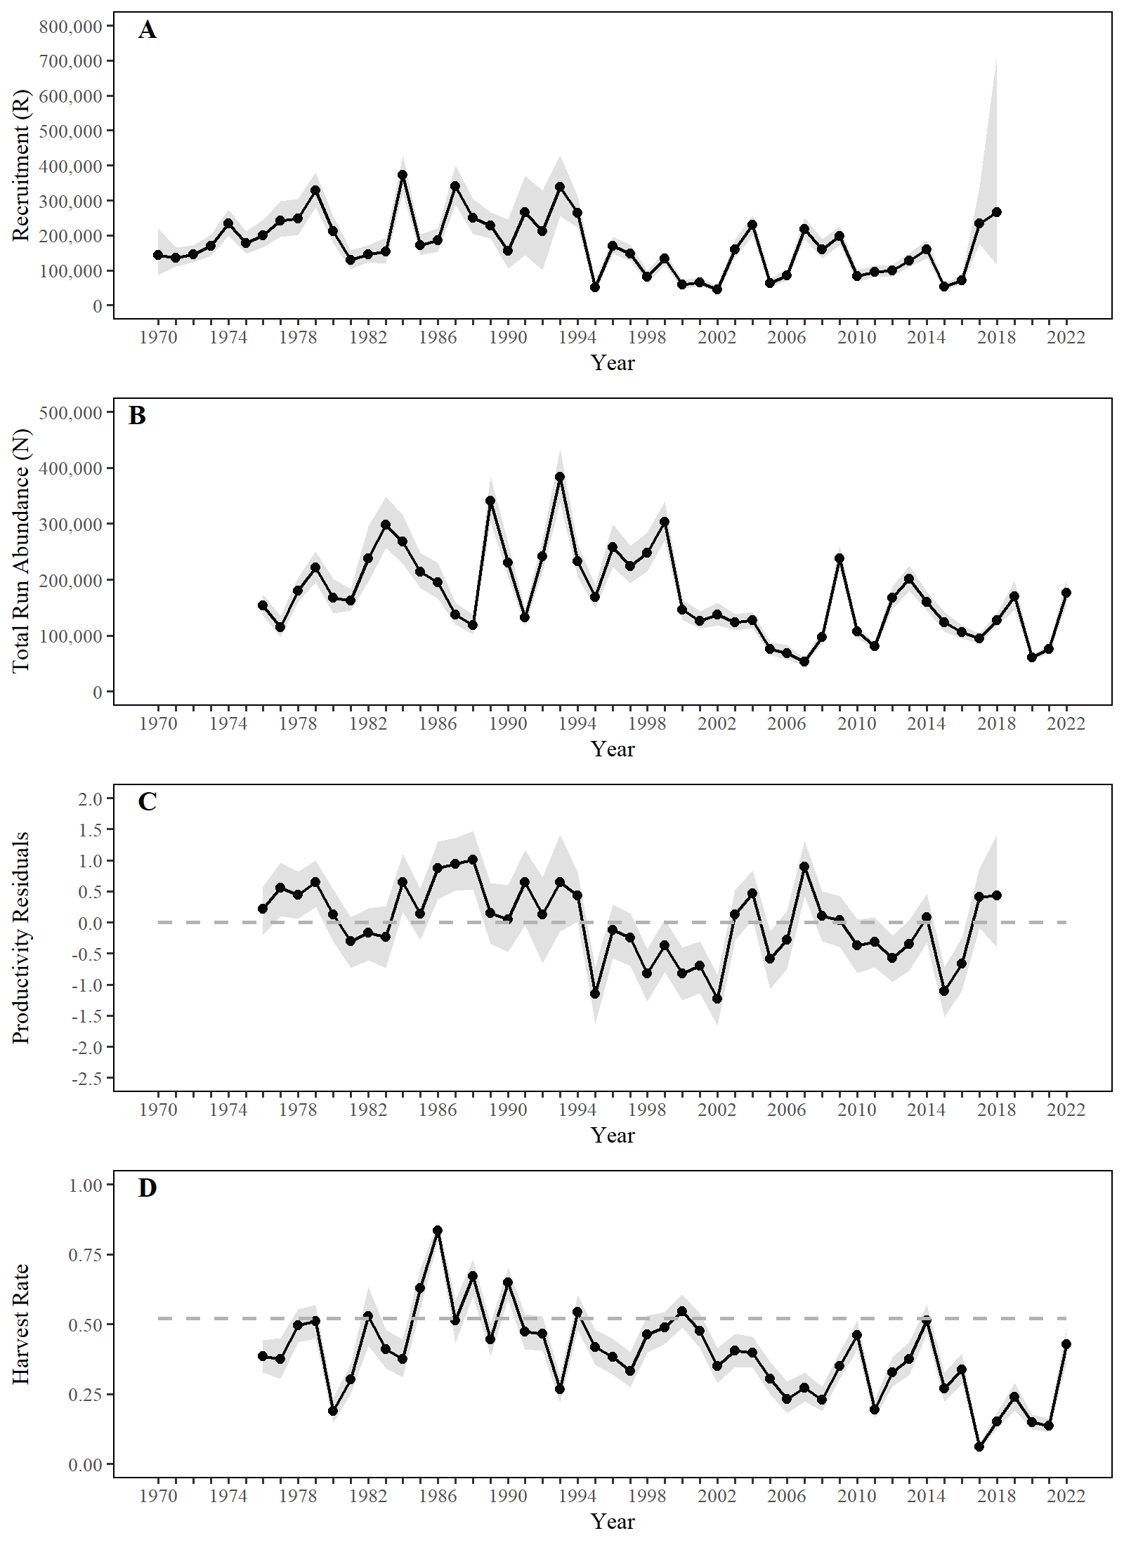

**Figure 2.**– Point estimates (posterior medians; circles) and 95% credible intervals (shaded areas) of escapement, recruitment by brood year, total run abundance, Ricker productivity residuals by brood year, and harvest rates from a state-space model of Chilkat Lake sockeye salmon, 1976–2022. The dotted line in Figure C is a reference line. The posterior median of *U*MSY is plotted as a dashed horizontal reference line in Figure D.

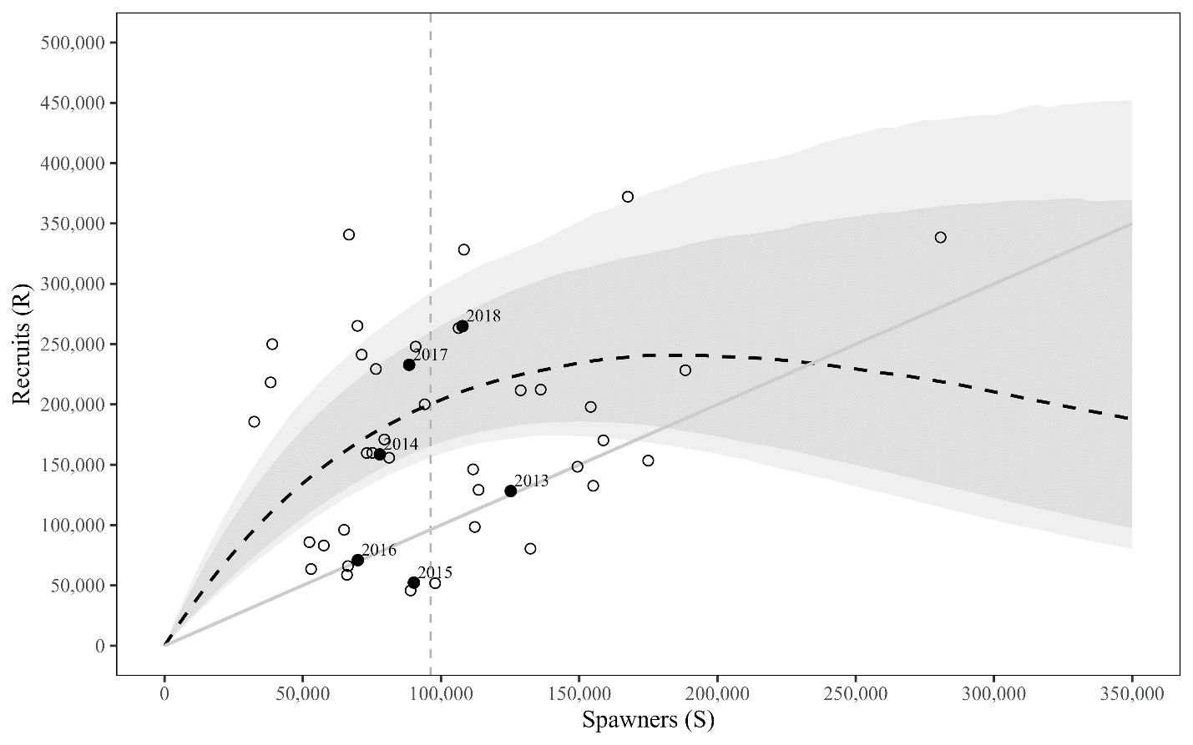

**Figure 3.**– Plausible spawner-recruit relationships for Chilkat Lake sockeye salmon as derived from an age-structured state-space model fitted to abundance, harvest, and age data for brood years 1976–2018. Posterior medians of recruits and spawners are plotted as brood year labels with 95% credible intervals (open circles). The solid black circles are the six most recent years of data (brood years 2013–2018). The heavy dashed line is the Ricker relationship constructed from ln(*α*’) and *β* posterior medians with 90% and 95% credibility intervals (shaded areas). Recruits replace spawners on the solid diagonal line. The vertical dotted (grey) line is the posterior median of *S*MSY.

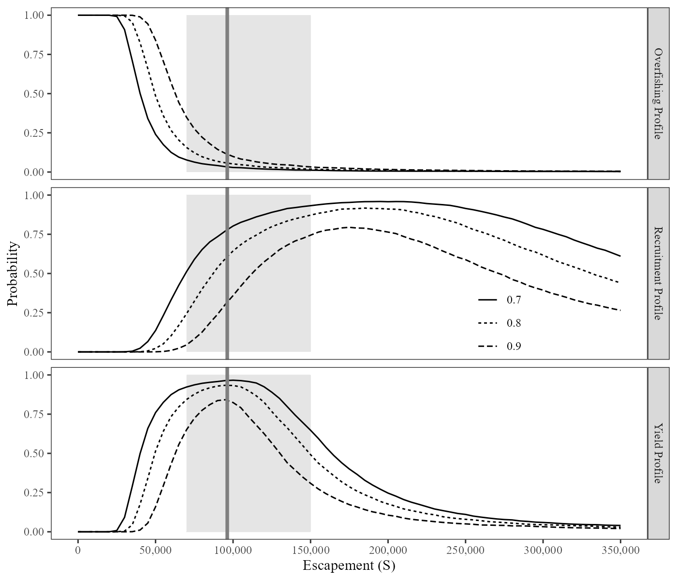

**Figure 4.**–Overfishing profiles (OFPs), optimal recruitment profiles (ORPs), and optimal yield profiles (OYPs) for Chilkat Lake sockeye salmon. OYPs and ORPs show probability that a specified spawning abundance will result in specified fractions (70%, 80%, and 90% line) of maximum sustained yield or maximum recruitment. OFPs show the probability that reducing escapement to a specified spawning abundance will result in less than specified fractions of maximum sustained yield. The shaded region shows the current biological escapement goal range of 70,000 to 150,000 spawners and the solid vertical line is the posterior median of spawning abundance at maximum sustained yield (*S*MSY) obtained from the state-space model.